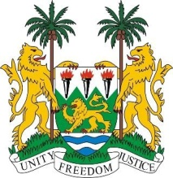
SIERRA LEONE

26th session of the UPR

VENEZUELA

STATEMENT BY SIERRA LEONE

1 November 2016

Mr President,

Sierra Leone extends a warm welcome to the high-level delegation from the Bolivarian Republic of Venezuela and thanks them for today’s presentation.

My delegation is pleased to note that the government has put in place new strategies to better integrate human rights norms into daily practice, including through the establishment of a National Human Rights Council in 2014. Also noteworthy are the creation of the National Human Rights action Plan 2016 – 2019, and the Second Socialist Plan for the Economic and Social Development of the Nation 2013 – 2019.

It is commendable that 96% of the population has access to drinking water and the government provides free universal access to anti-retroviral treatment.

Sierra Leone encourages the government to consider ratifying the ILO Convention No. 189, and acceding to the Convention relating to the Status of Refugees, in order to further protect the rights of refugees and asylum seekers and strengthen the Refugees and Asylum Seekers Act of 2001.

Recommendations:

- Ratify and accede to the ICRMW and the ICPPED.
- Further promote the equal and full participation of women in positions of power and high levels of decision-making posts.
- Establish legislation prohibiting racial discrimination and the incitement to racial hatred
- Promote the political participation of Afro-descendants and afford them and indigenous communities better protection against discrimination.

Sierra Leone wishes the Bolivarian Republic of Venezuela every success is completing this UPR session.

Thank you, Mr President.

